Database Portfolio 1 – 18001399

**Conceptual Design**

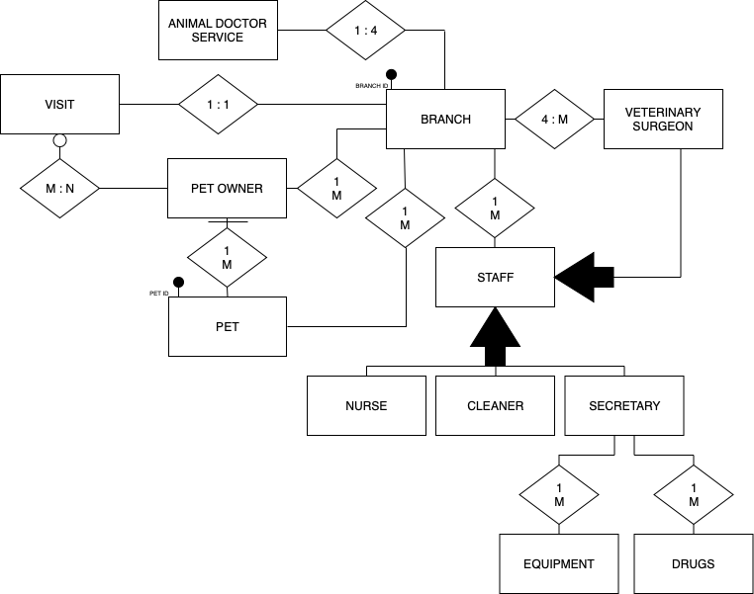

**Diagram Script**

|  |  |  |  |
| --- | --- | --- | --- |
| Entity | Attributes | Synonym | Relationships |
| AnimalDoctorService |  |  | Branch |
| Branch | BranchID,  PostalAddress, PhoneNumbers, |  | AnimalDoctorService, Staff, Visit, Pet, PetOwner, VeterinarySurgeon |
| Staff | Name, Address, PhoneNumber, StartDate, JobType, JobDescription, Salary |  | Branch, Secretary, VeterinarySurgeon |
| Nurse |  |  | Staff |
| Cleaner |  |  | Staff |
| Secretary |  |  | Staff, Equipment, Drugs |
| VeterinarySurgeon |  |  | Branch, Staff |
| PetOwner | Name, Address, PhoneNumber, |  | Branch, Pet, Visit |
| Pet | PetID, Details |  | Branch, PetOwner |
| Visit | Date, Time, Surgeon, Diagnoses, Treatment, DrugPrescribed |  | Branch, Pet |
| Equipment | EquipmentType |  | Secretary |
| Drugs | DrugType, DrugInformation, Quantity |  | Secretary |
| Relationship between Secretary and Drugs | Re-orderDetails |  | Secretary, Drugs |